- This week's UK inflation and labour market releases left the Monetary Policy Committee on track to cut interest rates by another 25bps in August. But with data revisions suggesting the scale of recent job losses was much smaller than previously thought, the chances of the MPC upping the pace of rate cuts appear to have receded.
- Official labour market data remains a mess. As well as large, narrative-changing revisions to the HMRC series, there remains a wide divergence between the various counts of employees. And though the Office for National Statistics claims data collection and sampling changes have improved the reliability of the Labour Force Survey, recent data looks implausibly strong.
In our response to the minutes of June's Monetary Policy Committee meeting, we argued that an August rate cut looked certain unless there was a major upside surprise in this week's inflation or labour market releases. In the event, the data left an August rate cut firmly on track.
Both we and the consensus had expected CPI inflation to be flat in June, but it rose 0.2ppts to 3.6%. Some of the upside surprise was due to higher readings in two of the volatile categories, air fares and clothing prices, and this will likely unwind in the near future. There was another strong reading for food prices. Services inflation also came in a little higher than anticipated and the steady downward trend in the Bank of England's favoured measure, which excludes some of the more volatile components, was interrupted (Chart 1). But given the dovish tone of June's MPC minutes, it's hard to believe that this release was strong enough to have a material impact on the committee's thinking.
The subsequent labour market release was mixed. Pay growth continued to cool, with private sector regular pay – the BoE's favoured measure – dipping below 5% in the three months to May. And the three-month-on-three-month annualised rate – a better guide to recent momentum – dropped to 3.7%. This suggests that settlements are getting closer to the pace the MPC considers to be consistent with achieving the inflation target over the medium-term.
Chart 1: Inflation surprised on the upside in June, with sticky core services inflation partly to blame
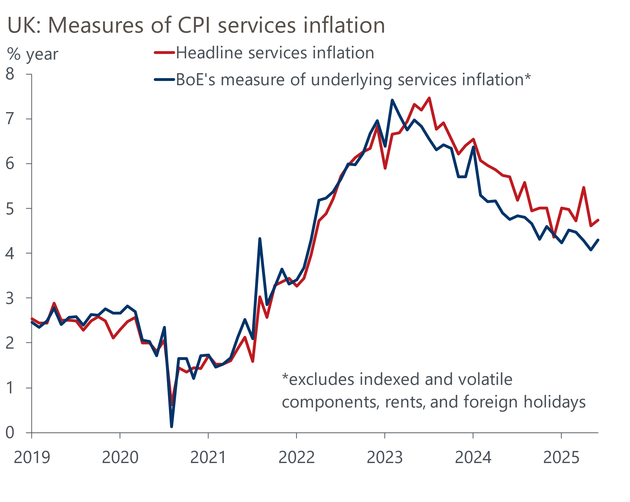
Source: Oxford Economics calculations using data from Haver Analytics

The main cause of the MPC's dovish tilt in June was concern at the pace at which labour market conditions were loosening in response to April's increase in employers' national insurance contributions. A 109,000 month-on-month fall in HMRC's count of the number of employees on payrolls in May was the main trigger for these worries. But that drop was revised down to just 25,000 in this week's update. In a recent note, we'd flagged that recent experience suggested the initial estimate would probably be upgraded, but the revision was one of the largest in recent years (Chart 2). The first estimate for June reported a 41,000 fall, at the lower end of the range of provisional outturns for job losses seen in recent months.
Chart 2: May's large fall in payrolled employees was revised much lower in the latest release
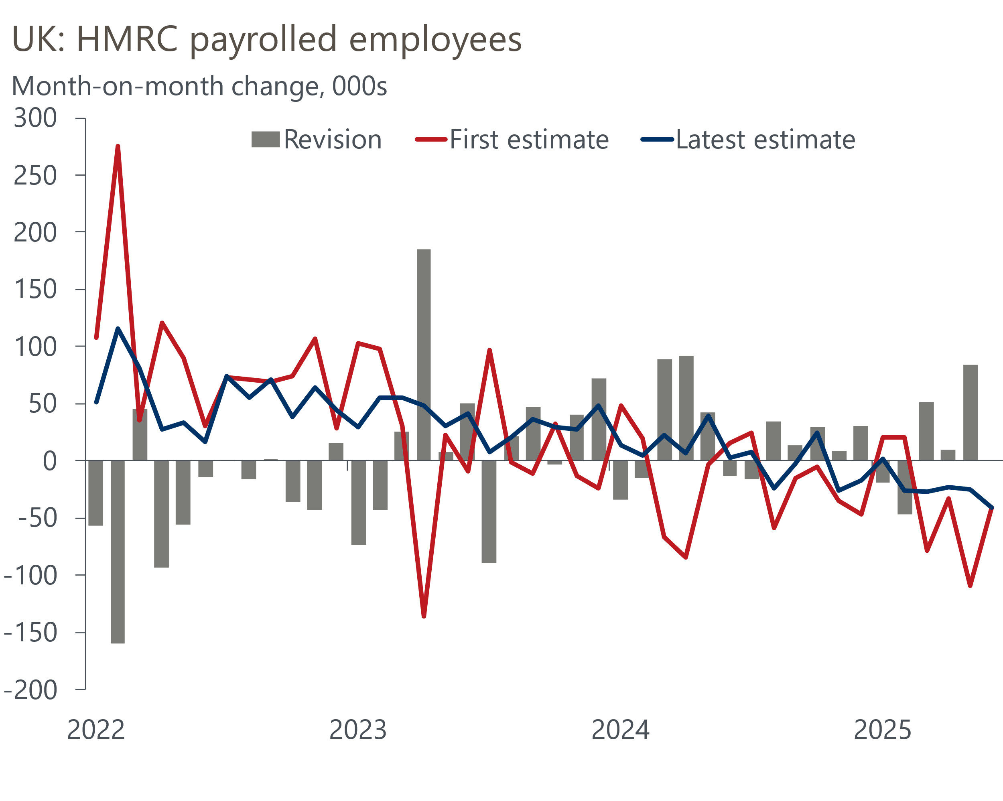
Source: Oxford Economics calculations using data from ONS
The dire state of the UK's labour market data has been a constant theme of our research over the past couple of years, and there's no sign of the situation improving. As well as the HMRC series being prone to large, narrative-changing revisions, there's a wide divergence in the picture reported by the UK's three main measures of employees. Notwithstanding the revisions, the HMRC series shows the number of employees falling in nine of the past 12 months to stand just over 100,000 lower than last summer. By contrast, the Office for National Statistics' equivalent workforce jobs and Labour Force Survey series show employee growth of 300,000-400,000 over the same period.
We've covered the problems with the LFS extensively. The ONS believes the estimates they've published this year are more representative of labour market conditions because they incorporate improvements in data collection and sampling methods. But with the data for the March to May period reporting strong employment growth despite the increase in NICs coming into force, the data retains an air of implausibility.
That the labour market data is in such a state of disrepair makes life much harder for the MPC. Despite the revisions to the HMRC series, we suspect most of the committee will conclude that there's still plenty of evidence that labour market conditions are loosening. In particular, the number of job vacancies dropped again in the three months to June, reaching its lowest level in more than four years. With pay growth continuing to cool and Bank Rate still well above the level that most committee members would consider to be neutral, it would be a major surprise if the MPC didn't cut Bank Rate by another 25bps on August 7.
But while the likelihood of an August cut hasn’t changed, we do think this week's data has made it much less likely that the MPC breaks with its cut-hold tempo and loosens policy more quickly over the latter part of the year. For most members, we suspect the slower pace of job losses indicated by the latest vintage of HMRC data significantly reduces the urgency of the situation. And concerns about underlying inflation pressures have rarely been far from the surface for a very cautious committee. Things would need to go very wrong, very quickly, with either the labour market or activity data to put a September cut on the table. And even a December cut looks less likely than it did at the start of this week.

The week ahead
The PMIs plunged in April in response to US tariff policy announcements and the increase in employers' national insurance contributions going into force, but recent surveys have reported stronger results, with the composite PMI reaching a nine-month high in June. We expect July's flash S&P Global survey to consolidate those gains, with the composite PMI coming in at 52.2. The large gap between services and manufacturing is likely to persist.
After a series of strong readings, retail sales plunged 2.7% m/m in May. Though all the main sectors reported lower sales, a 5% m/m drop in sales in food stores accounted for the bulk of the weakness. Given this took the level of food sales well below recent norms, we think there's scope for a strong rebound in June's data. We pencil in a 1.2% m/m increase in retail sales in June.
Table 1: Week ahead calendar
Date | Events | Period | Measure | Unit | Previous | Forecast
Jul 22 | Public finances | Jun | PSNB ex | £bn | 17.7 | 15.0
Jul 24 | S&P Global manufacturing | Jul | PMI | % bal | 47.7 | 48.0
Jul 24 | S&P Global services | Jul | PMI | % bal | 52.8 | 53.0
Jul 24 | S&P Global composite | Jul | PMI | % bal | 52.0 | 52.2
Jul 25 | GfK consumer confidence | Jul | Headline | % bal | -18 | -20
Jul 25 | Retail sales inc fuel | Jun | m/m | % | -2.7 | 1.2
Jul 25 | Retail sales inc fuel | Jun | y/y | % | -1.3 | 1.5
Source: Oxford Economics

Key forecasts
Table 2: UK forecast overview
(Annual percentage changes unless specified)
 | 2023 | 2024 | 2025 | 2026 | 2027 | 2028
GDP | 0.4 | 1.1 | 1.1 | 0.9 | 1.3 | 1.8
Private consumption | 0.5 | 0.6 | 1.1 | 1.1 | 1.2 | 1.8
Fixed investment | 0.3 | 1.5 | 1.8 | 0.8 | 1.6 | 2.0
Government consumption | 1.6 | 3.0 | 1.5 | 1.7 | 1.6 | 1.7
Exports of goods and services | -0.4 | -1.2 | 1.2 | 0.1 | 1.2 | 1.4
Imports of goods and services | -1.2 | 2.7 | 3.4 | -1.3 | 1.1 | 1.4
Industrial Production | -0.8 | -1.2 | 0.0 | -0.5 | 0.7 | 1.2
Consumer prices | 7.3 | 2.5 | 3.4 | 2.7 | 2.4 | 2.1
Unemployment rate (%) | 4.1 | 4.3 | 4.7 | 4.9 | 4.8 | 4.5
Current a/c balance (% of GDP) | -3.5 | -2.7 | -3.3 | -2.9 | -2.7 | -2.7
Government balance (% of GDP) | 5.2 | 5.1 | 4.3 | 3.6 | 3.0 | 2.7
Central bank policy rate (%, EOP) | 5.25 | 4.75 | 3.75 | 3.00 | 2.50 | 2.50
10yr govt. bond yield (%, EOP) | 3.54 | 4.57 | 4.55 | 4.04 | 3.47 | 3.35
Exchange rate (US$ per £, EOP) | 1.27 | 1.25 | 1.36 | 1.36 | 1.36 | 1.36
Exchange rate (euro per £, EOP) | 1.15 | 1.21 | 1.17 | 1.17 | 1.17 | 1.17
Source: Oxford Economics
Table 3: Quarterly forecasts for the UK
 | 2025 |  |  |  | 2026
 | Q1 | Q2 | Q3 | Q4 | Q1 | Q2 | Q3 | Q4
GDP (% year) | 1.3 | 0.9 | 1.1 | 1.2 | 0.7 | 0.8 | 0.9 | 1.0
CPI inflation (% year) | 2.8 | 3.5 | 3.8 | 3.5 | 3.3 | 2.5 | 2.5 | 2.5
Bank Rate (%, EOP) | 4.50 | 4.25 | 4.00 | 3.75 | 3.50 | 3.25 | 3.25 | 3.00
10yr gilt yield (%, EOP) | 4.70 | 4.48 | 4.60 | 4.55 | 4.48 | 4.35 | 4.20 | 4.04
US$ per £ (EOP) | 1.29 | 1.37 | 1.36 | 1.36 | 1.36 | 1.36 | 1.36 | 1.36
Euro per £ (EOP) | 1.20 | 1.17 | 1.17 | 1.17 | 1.17 | 1.17 | 1.17 | 1.17
Source: Oxford Economics

Latest Country Economic Forecast:
July 17, 2025

Recent publications

Data Insights
Widening labour market cracks keep August rate cut on track
Small upside surprise for inflation won't derail an August rate cut
GDP falls again as momentum slows
PMIs suggest growth was relatively soft in Q2
Manufacturing sector struggles on

Research Briefings
BoE likely to slow QT to avoid adding to gilt market strains
How the sectoral mix of jobs is changing and what it means
MPC’s dovish hold boosts the chances of an August cut
MPC Preview – Divided committee to pause in June
Unconvincing spending review is another fiscal stopgap

Contacts

Oxford Economics' UK team
- Andrew Goodwin - Chief UK Economist - agoodwin@oxfordeconomics.com
- Edward Allenby - UK Economist - eallenby@oxfordeconomics.com

